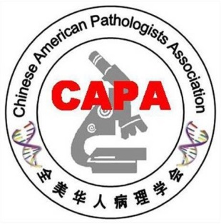
2019 CAPA Annual Meeting Call for Abstracts for CAPA-MOTIC Best Abstract Award

On behalf of the Chinese American Pathologists Association (CAPA), we are delighted to call for abstract for the 2019 CAPA-Motic Best Abstract Award for junior practicing pathologists and pathologists-in-training in China.
CAPA’s major missions are to promote excellence in practice, education and research in pathology, as well as advocacy on behalf of pathologists of Chinese origin. The objectives of this Best Abstract Award are to encourage and reward outstanding research contributions by pathologists in China, and to foster the communication and collaboration among pathologists practicing in China and those in the CAPA community. Please visit our website at www.capaht.org for more information.

Eligibility:
- First-authored abstract(s) by a junior practicing pathologist (instructor, attending pathologist, or below) or pathologist-in-training (pathology resident) in China are qualified to be considered and the abstracts must have been accepted for platform or poster presentation at the USCAP Annual Meeting 2019. The projects must have been conducted and completed in Mainland China. We will contact USCAP’s director of Education in November of 2018 to obtain a list of accepted abstracts from Mainland China. The submitting author will be contacted for their interest in entering CAPA-MOTIC BEST ABSTRACT AWARD competition. The submitting author can use their accepted USCAP 2019 abstracts to compete for this award.
- One individual can submit more than one abstracts, but only one award will be given to the same person. A copy of the USCAP acceptance letter must be submitted along with the corresponding abstract.
- One author of each winning abstract must attend the CAPA Annual Business Meeting, on March 16th, 2019 in National Harbor, Maryland, to receive the award. Otherwise the abstract will be automatically disqualified for the award.

Submission and Deadline:
Please submit abstract(s) together with your full contact information and the corresponding USCAP acceptance letter to the chair of CAPA Award Committee Dr. Xiuli Liu by email at xiuliliu@ufl.edu. The deadline for abstract submission is December 14 (Friday), 2018.
Selection:
Abstracts will be reviewed by members of the Selection Committee who are blinded to the information of authors and institutions. Each abstract will be scored independently by five reviewers. Abstracts with the highest average scores/ranks will be selected as the winners. We will notify the potential winners before the end of December 2018. One author of each winning abstract must attend the CAPA Annual Business Meeting, on March 16th, 2019 in National Harbor, Maryland, to receive the award. Otherwise the abstract will be automatically disqualified for the award at the time of meeting.
Recognition:
The awards will be presented to the winners in the afternoon, March 16, 2019 at the CAPA Annual Business Meeting during the upcoming 2019 USCAP Annual Meeting in National Harbor, Maryland, United States, March 16-21, 2019. Each winner will receive a certificate with his/her name, a cash award, and recognition on the CAPA website. One author of each winning abstract must be present at the CAPA Annual Business Meeting in person to receive the award.

Selection Committee:

Xiuli Liu, Professor of Pathology, University of Florida
Qinghu Ren, Assistant Professor of Pathology, University of New York
Jack Yang, Professor of Pathology, Medical University of South Carolina
Xinming Zhang, Professor of Pathology, Cooper University of Hospital, New Jersey
Yaxia Zhang, Hospital for Special Surgery, New York City
Jiehao Zhou, Assistant Professor of Pathology, Indiana University

